**PLSQL_Exercises - Answers**

Exercise 1 :

//Scenario 1   
  
BEGIN

FOR cust IN (SELECT customer_id FROM customers WHERE age > 60) LOOP

UPDATE loans

SET interest_rate = interest_rate - 1

WHERE customer_id = cust.customer_id;

END LOOP;

COMMIT;

END;

//Scenario 2

BEGIN

FOR cust IN (SELECT customer_id, balance FROM customers) LOOP

IF cust.balance > 10000 THEN

UPDATE customers

SET is_vip = 'TRUE'

WHERE customer_id = cust.customer_id;

END IF;

END LOOP;

COMMIT;

END;

// Scenario 3

DECLARE

CURSOR due_loans IS

SELECT l.loan_id, l.customer_id, c.name, l.due_date

FROM loans l

JOIN customers c ON l.customer_id = c.customer_id

WHERE l.due_date <= SYSDATE + 30;

BEGIN

FOR loan IN due_loans LOOP

DBMS_OUTPUT.PUT_LINE('Reminder: Loan ID ' || loan.loan_id ||

' for customer ' || loan.name ||

' is due on ' || TO_CHAR(loan.due_date, 'DD-MON-YYYY'));

END LOOP;

END;

Exercise 3

//Scenario 1

CREATE OR REPLACE PROCEDURE ProcessMonthlyInterest AS

BEGIN

UPDATE accounts

SET balance = balance + (balance * 0.01)

WHERE account_type = 'SAVINGS';

COMMIT;

END;

//Scenario 2

CREATE OR REPLACE PROCEDURE UpdateEmployeeBonus(

p_dept_id IN NUMBER,

p_bonus_pct IN NUMBER

) AS

BEGIN

UPDATE employees

SET salary = salary + (salary * p_bonus_pct)

WHERE department_id = p_dept_id;

COMMIT;

END;

//Scenario 3

CREATE OR REPLACE PROCEDURE TransferFunds(

p_from_acc IN NUMBER,

p_to_acc IN NUMBER,

p_amount IN NUMBER

) AS

v_balance NUMBER;

BEGIN

SELECT balance INTO v_balance

FROM accounts

WHERE account_id = p_from_acc

FOR UPDATE;

IF v_balance < p_amount THEN

RAISE_APPLICATION_ERROR(-20001, 'Insufficient funds in source account');

END IF;

UPDATE accounts

SET balance = balance - p_amount

WHERE account_id = p_from_acc;

UPDATE accounts

SET balance = balance + p_amount

WHERE account_id = p_to_acc;

COMMIT;

END;

**Junit Basic Testing Exercises:**

Exercise 1:

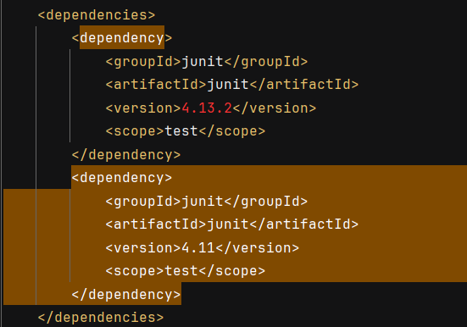

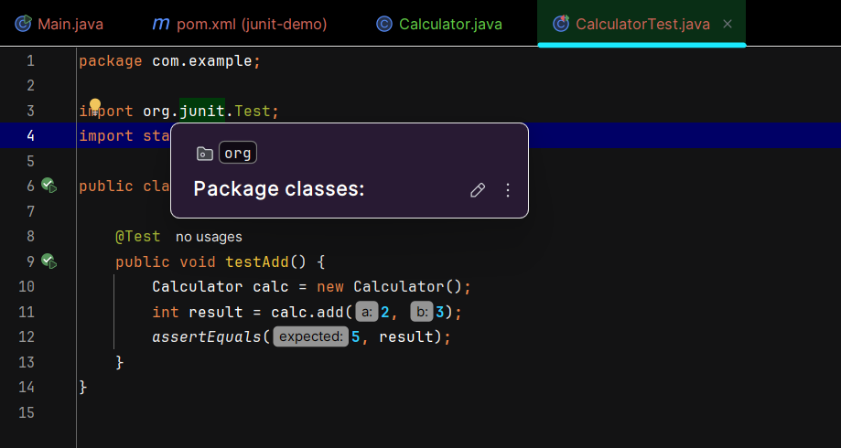

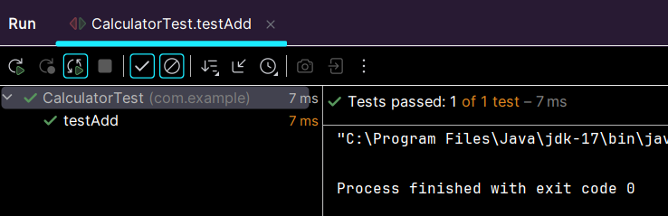

Exercise 3:

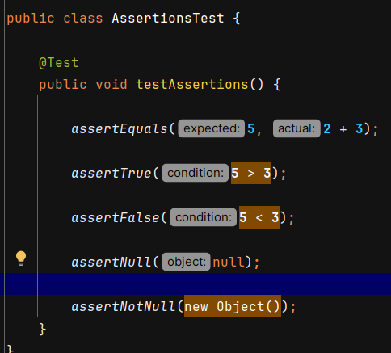

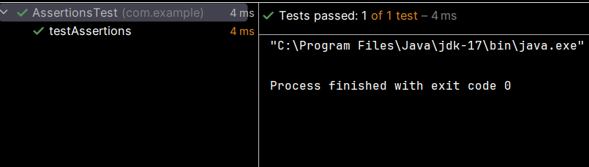

Exercise 4:

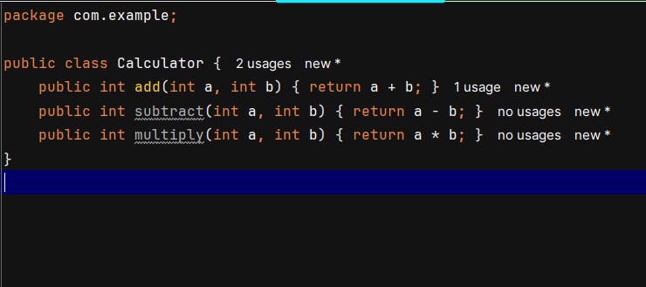

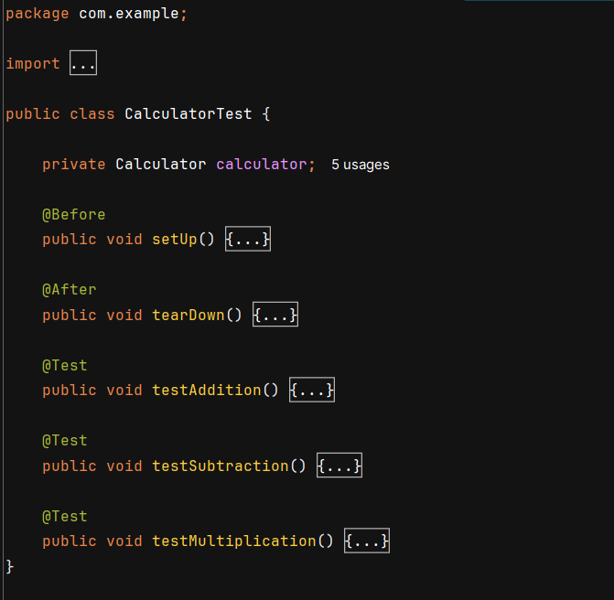

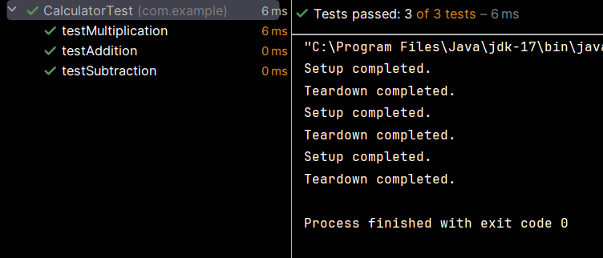

**Mockito Exercises**

Exercise 1:

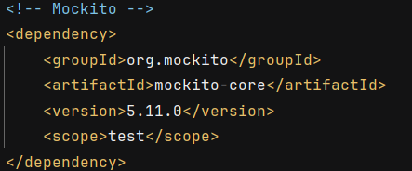

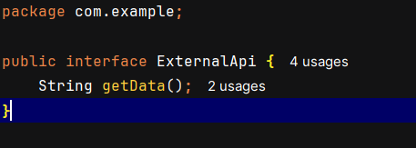

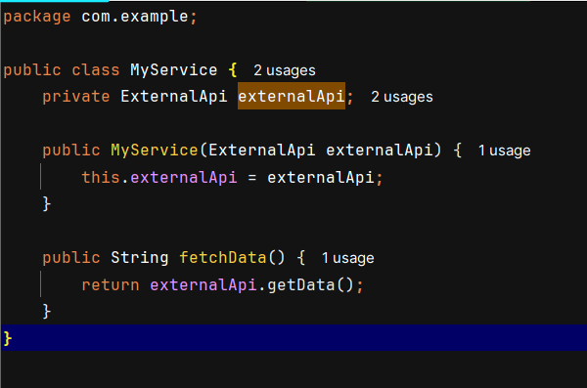

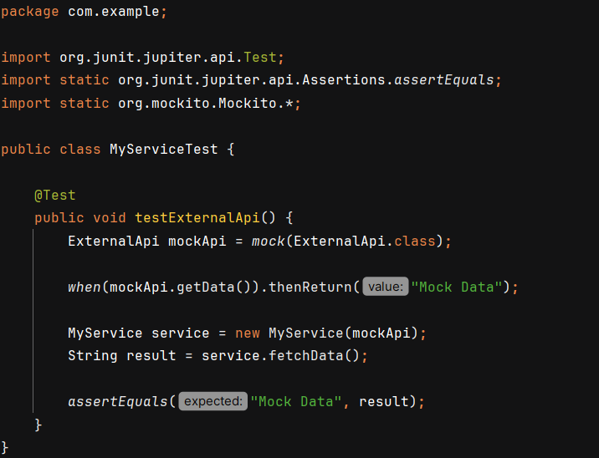

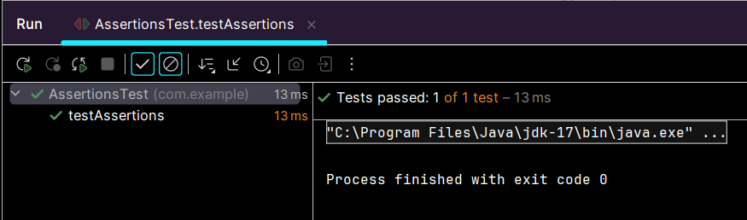

Exercise 2:

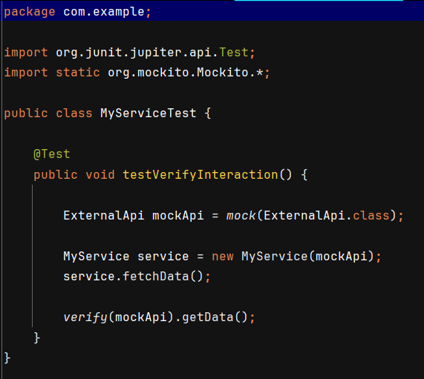

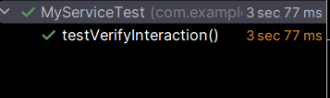

**Logging using SLF4J**

